Travis Cunnington
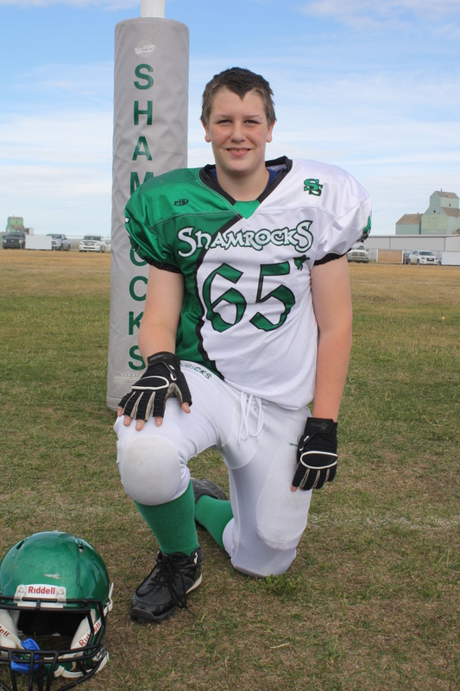
In my life I have had many fun and exciting moments in my life. My favorite memory was in 2014 when we drove all the way to ontario with my family, we have family all over Canada so we stopped pretty much in every province. My favorite stop was in saskatchewan when I got to see my nephew Oakley. After we stopped in saskatchewan we saw my grandparents on my dad's side in manitoba, it was a fun stop by, I haven't seen them since I was, well I can’t actually remember it’s been so long. But anyways after Manitoba we left for Ontario. We took the way through the U.S. and we had to go through detroit. We actually got lost in detroit when my mom made a wrong turn one time and that was really scary. We ended up in a pretty bad neighborhood but finally got out of it and made it to my aunt's house. We stayed at my aunties for about two weeks then made our way home, going the same way with almost the same stops. After we got home we tried to go back to a normal lifestyle, but it took us a couple weeks to shake off all the late nights and driving. We finally Adapted to our normal routines and everything was back to normal. That same summer our family decided to move to the beautiful town of sexsmith. I moved into Sexsmith St.Mary's school and I love it. So far, I have had a pretty good life.

